Ears
The production of ear wax also known as cerumen is normal. Its job is to trap debris and provide protection for the ear canal and ear drum, however some people produce more wax than others.
A build up of wax may be problematic, but can usually be easily resolved with the use of oil or drops. With continued use of drops the wax should soften and fall out your ear, however there may be a time you may need ear irrigation, but this is not a first line treatment.
Ear Advice
The ear should be self-cleaning. Using the likes of cotton buds to try and remove wax mostly pushes the wax further down the ear canal and may compact it and cause trauma to the canal lining. If you suffer with recurrent problems with wax blocking your ears then regular use of olive oil may help prevent this. Problems to the ear, such as dry skin, eczema and dermatitis should improve by keeping the ears dry and regularly using olive oil to moisturise the ear. Hearing aids can interfere with the ears natural process

of shedding dead skin and wax therefore regular use of olive may help prevent it from building up in the ear canal. People
with narrow ear canals or who work in dirty or dusty environments may find that the dust/dirt mixes with any wax and forms a plug. Regular use of olive may help prevent this.

Ear irrigation will not be carried out routinely.
Ear irrigation is the process of removing wax from the ear canal using a jet of warm water. The water will flow behind the plug of wax and back along the ear canal to gently remove the wax from the ear canal.

Risks
Ear irrigation carries a risk of perforation to the ear drum. After the procedure there is a risk of developing an ear infection. Therefore it is a last resort.

Ears will be will be assessed by the nurse to determine the best course of treatment & advice will be given if a future appointment is required.

Process to instil eardrops
To aid the removal of the wax more effectively from the ear prior to irrigation, it is important for the wax to be softened first. This can be done by
Instilling olive oil drops at least twice daily into the affected ear for a minimum of 3 weeks before your appointment date.

Gently pull the outer ear backwards and upwards and with the dropper, drop 2-5 drops into the ear canal at least twice daily. Do this right up until the day of your appointment.

Gently massage the small thick flap of skin at the bottom of the ear for a few minutes.

Remain lying down for 10 minutes. When you get up wipe away any excess oil.

If the nurse assesses your ear and the wax isn’t sufficiently softened you will be asked to continue to administer ear drops for a further period of time.

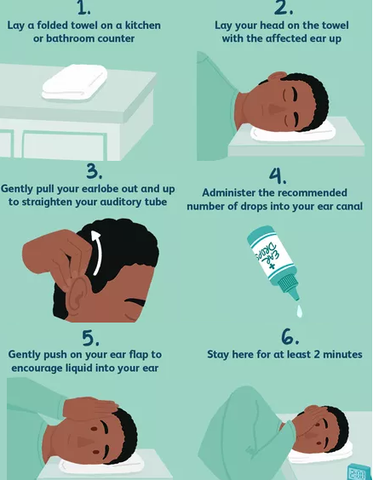

EAR CARE

EAR ASSESSMENT

