**FOR THE PATIENT NEAR ME VIDEO CONSULTATIONS**

Search for “The Whins Medical Practice” website [www.thewhinsmedicalpractice.co.uk](http://www.thewhinsmedicalpractice.co.uk)

On the front page of the website locate the Near Me logo and click on the link at the side <https://nhsattend.vc/fv-whins>

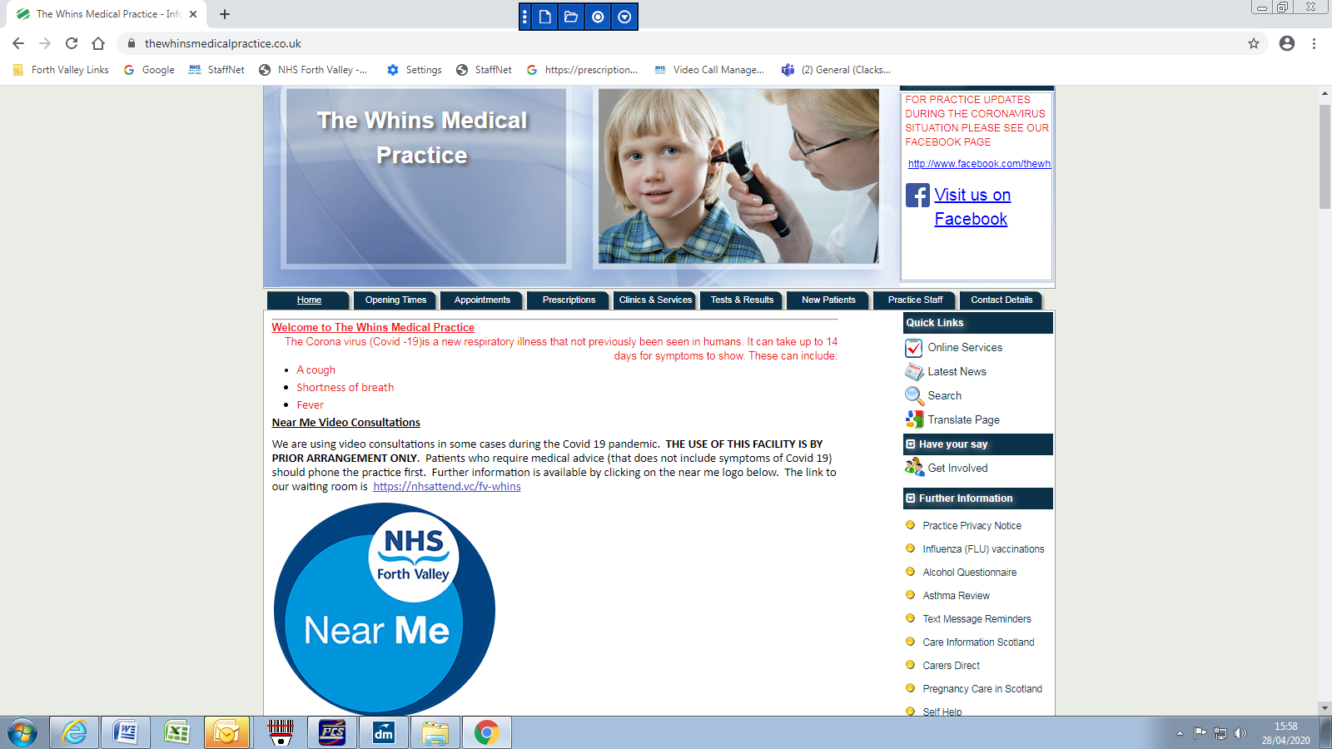

Click on Start video call

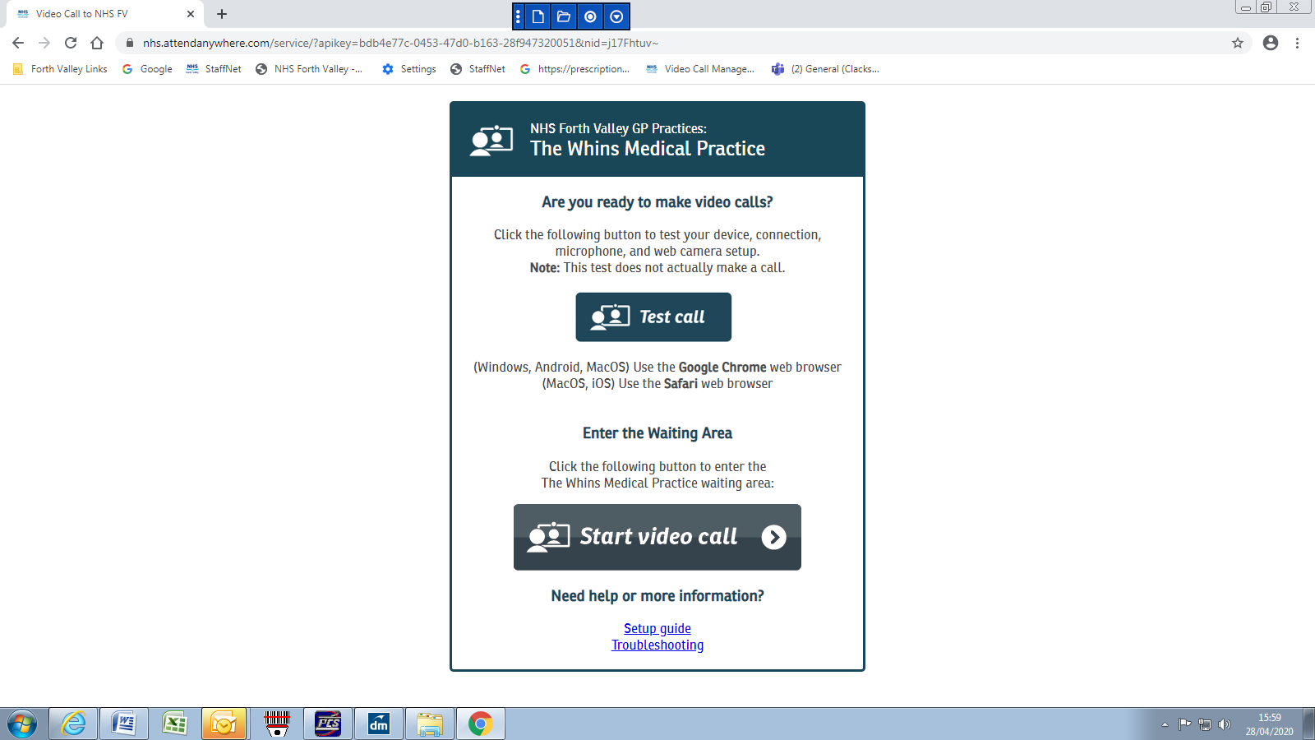

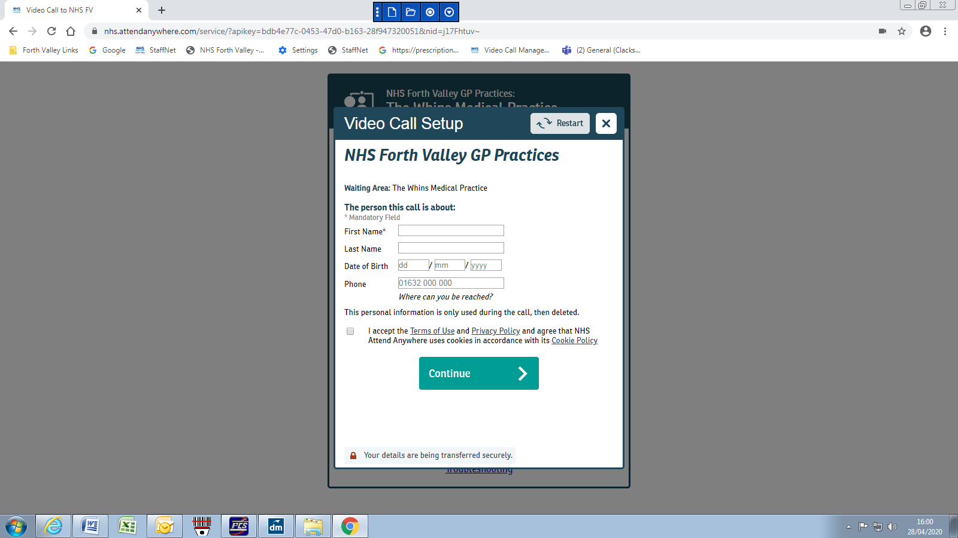

Type in personal details and click on continue

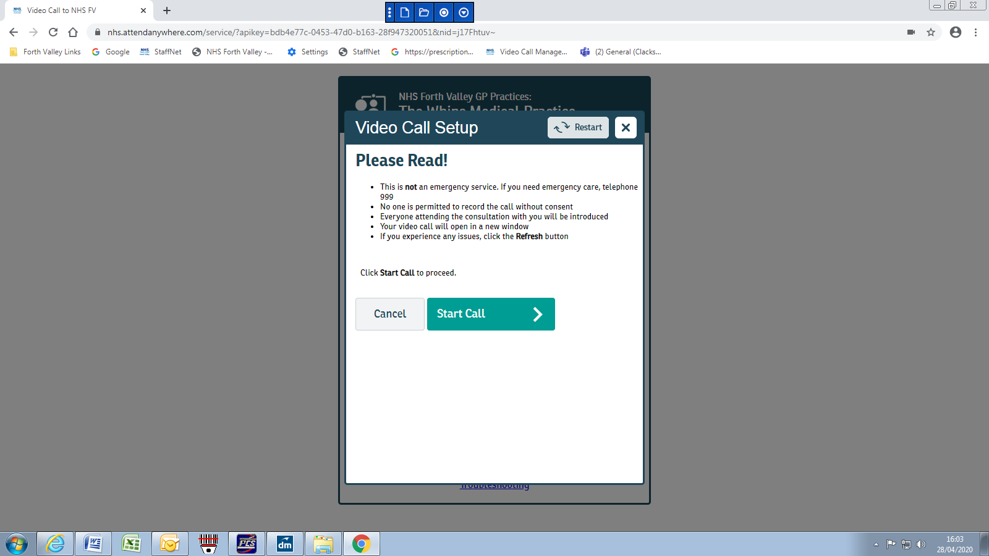

Click on Start Call